PSHE BOOKS
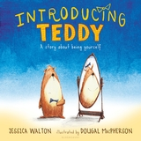 By Jessica Walton
Errol and his teddy, Thomas, are best friends who do everything together. Whether it's riding a bike, playing in the tree house, having a tea party or all of the above, every day holds something fun to do together. One sunny day, Errol finds that Thomas the Teddy is sad, and Errol can't figure out why. Then Thomas the Teddy finally tells Errol what Teddy has been afraid to say: 'In my heart, I've always known that I'm a girl teddy, not a boy teddy. I wish my name was Tilly.' And Errol says, 'I don't care if you're a girl teddy or a boy teddy! What matters is that you are my friend.'A sweet and gentle story about being true to yourself and being a good friend, Introducing Teddy can also help children understand gender identity.

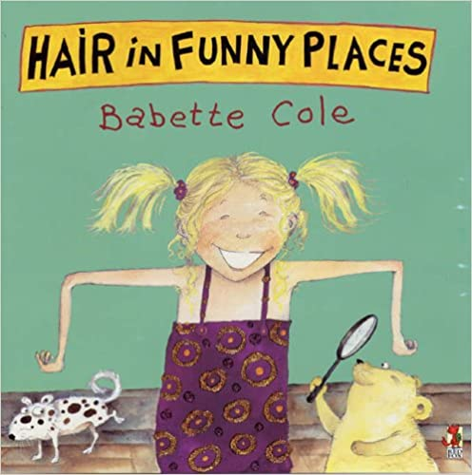 By Babette Cole

Girls and boys are always curious and sometimes even alarmed by the behaviour of their bodies as they grow up. Puberty being a particularly unsettling time, Babette Cole has made this the subject of the fifth title in her bestselling series of 'family dilemmas'. Who else but Babette would have the temerity to tackle this subject in a picture book and the genius to carry it off! In Hair in Funny Places her artwork is without exaggeration some of the best she has ever done: it is brilliant. The text takes the form of a conversation between a small girl and her teddy bear, and is ingenious and funny. It is the behaviour of Mr and Mrs Hormone (wonderfully depicted) which is responsible for and plays havoc with the physical and emotional states of girls and boys throughout puberty. This book is bound to be controversial but Babette has never taken the conventional path and her readers love her for her outrageous approach to little mentioned topics.

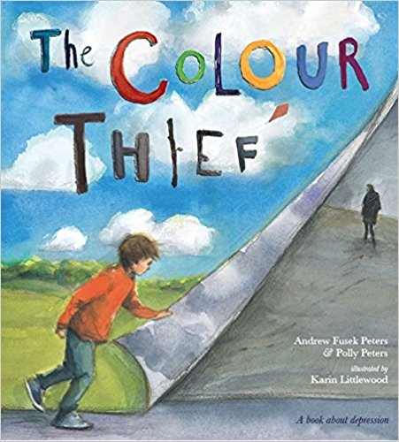 By Andrew Fusek Peters
The Colour Thief is a simple, heart-warming tale which helps to open up the conversations around depression and to support young children whose families have been affected.We follow a young boy who loves spending time with his dad, doing fun things together. When his father becomes sad and distant, he doesn't understand and believes he has done something to make his dad so, despite being told otherwise. Time passes and his father begins to get happier again and they have fun together like before. Narrated from the child's perspective and illustrated with beautiful pictures by the award-winning artist Karin Littlewood, this is the perfect book to read with children aged 7-9 years old who are trying to understand the cause and effects of depression, and reassure them that depression passes and their parents are not lost to them.

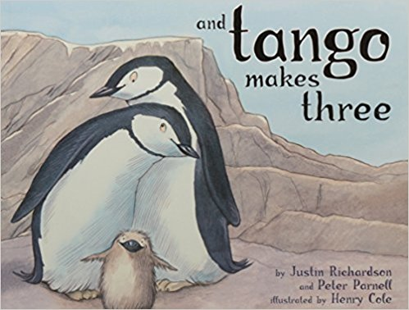 By Justin Richardson
The heart warming true story of two penguins that create a non traditional family is now available in a sturdy board book edition.
At the penguin house at the Central Park Zoo, two penguins named Roy and Silo were a little bit different from the others. But their desire for a family was the same. And with the help of a kindly zookeeper, Roy and Silo got the chance to welcome a baby penguin of their very own.

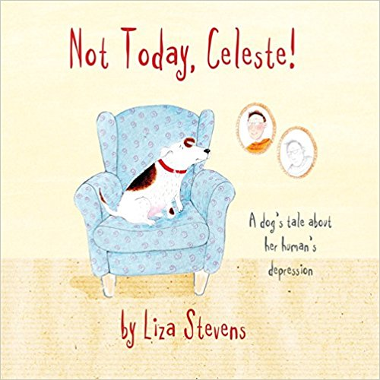 By Liza Stevens

Celeste thinks she is the happiest dog in the world. But when she notices something different about her human, Rupert, she wonders if things will ever be the same again.
Charmingly illustrated, this heart-warming story for children aged 3+ reflects some of the feelings and experiences that a child whose parent or carer has depression may face. When it comes to periods of low mood in a parent or carer, children can often feel that they are to blame, or even that the parent doesn't love them anymore. The story provides reassurance by explaining what depression is and how it is possible to find help. With a comprehensive guide for parents and professionals written by Dr Pooky Knightsmith that provides advice on discussing the topic with children, this is a truly valuable resource that will be of interest to social workers, child and school counsellors, psychologists, parents and foster parents.

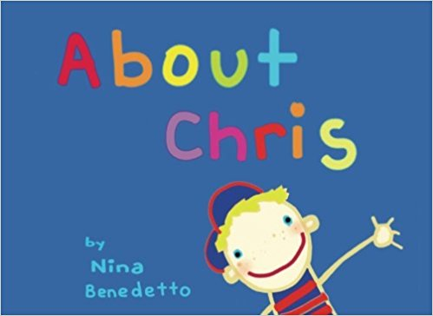 By Nina Benedetto

This story affirms the dignity and self-worth of a child who knows that he is a boy despite the fact that his body is female. Chris's story portrays his determination to be his true self, and the lesson his teacher learns.

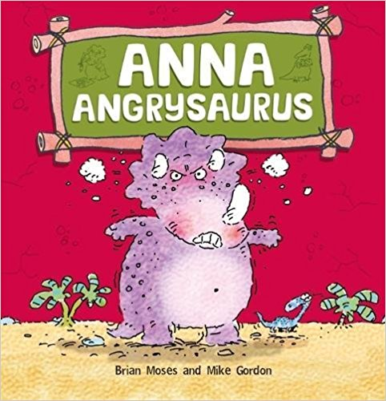 By Brian Moses

Anna Angrysaurus is a very angry dinosaur. She gets cross when her brother beats her at games, or when she can't watch what she wants on television. She roars, howls and stamps her feet. Will she ever be able to keep calm?
Written by Brian Moses, this funny picture book explores different things that might make young children frustrated at home or at school, such as sibling jealousy, not being allowed to do what they like, or even feeling grumpy for no reason at all. Different ways of dealing with anger and avoiding tantrums are then set out.
The clever and funny illustrations, by internationally renowned illustrator, Mike Gordon, bring a light touch to these stories, helping children to learn about and manage their emotions in a fun and light-hearted way.
Excellent notes for parents and teachers at the back of these books show how to approach these issues with children.

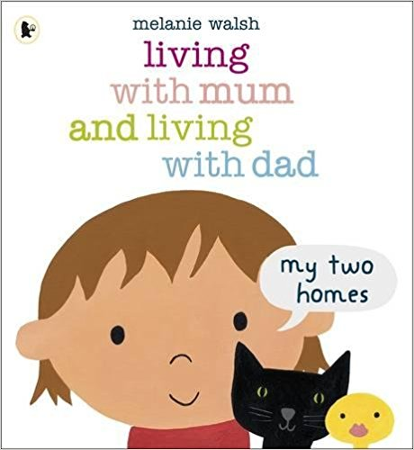 By Melanie Walsh
Mum and Dad don't live together anymore, so sometimes this little girl lives with her mum and her cat, and sometimes she lives with her dad. She has two bedrooms and two sets of toys, but she takes her favourite toys with her wherever she goes. This simple, warm, lift-the-flap book with bold and colourful illustrations is a reassuring representation of separation for the youngest children. Melanie Walsh is sympathetically alive to the changes in routine that are familiar to many children who live with separate parents and are loved by both.

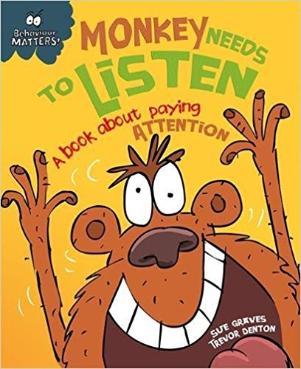 By Sue Graves
A lively picture book that examines the issue of not listening in an amusing but reassuring way through animal characters - perfect for young children who forget to listen. The story offers a gentle way in to reinforce this good behaviour. At the end of the story there are notes for parents and teachers with suggestions of ways to help children deal with anger.
Monkey is so excited about a go-kart race that he doesn't listen to any of the instructions. He doesn't stop to check his kart and he nearly ruins the race for all the animals. Can Monkey learn to listen and pay attention or will the race be abandoned for good?
It is part of a series Behaviour Matters, which is perfect for sharing with children as a gentle means of discussing their emotions, boosting self-esteem and reinforcing good behaviour. Each book has a fun story featuring fantastic characters which is backed up by suggestions for activities and ideas to talk through together. They support the Personal, Social and Emotional Development Area of Learning in the Early Years Foundation Stage.

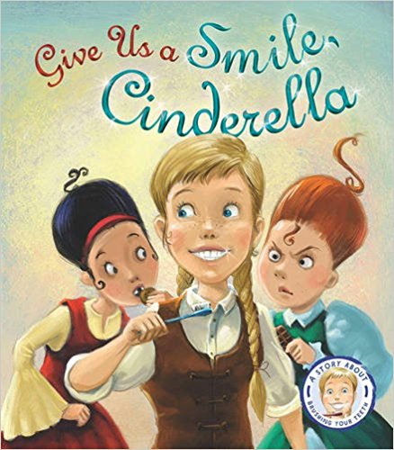 By Steve Smallman
Every day Cinderella brushes her teeth twice whilst her two sisters eat cakes and sweets all day, can her sparkling smile take her from rags to riches?
Follow Cinderella in this hilarious twist of the classic fairy tale and discover why it's important to brush your teeth.

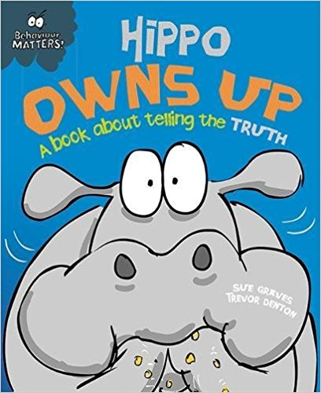 By Sue Graves
This funny, charming story is the perfect way to introduce young children to what honesty is, and help them understand the importance of owning up to your mistakes. Also included are suggestions for activities and ideas to talk through together to help children fully understand how their behaviour can impact on others.
Hippo is having a bad day. It all started when he missed his breakfast. He can't concentrate in class and his tummy won't stop rumbling. And when he sees Mrs Croc's special chocolate cake, he can't resist. Now somebody else is getting the blame for eating it. Will Hippo do the right thing and tell the truth and make amends for what he's done?
The Behaviour Matters series of picture books provide a gentle means of discussing emotions, boosting self-esteem and reinforcing good behaviour. Supports the Personal, Social and Emotional Development Area of Learning in the Early Years Foundation Stage, and is also suitable for use with children in KS1 and can be used to discuss values.

