

Highburton C.E First Academy CE Primary

Working together to improve school attendance

Key Information for

Parents/Carers

Based on statutory guidance from the Department for Education. Applies from: 19 August 2024

Working together to improve school attendance KEY MESSAGES


Attendance is one of the biggest challenges facing the school system today. Since the pandemic, there has been a worldwide rise in school absence and persistent absence. In response to this, the government are pressing ahead with tougher attendance rules, with new statutory guidance in place from August 2024.


Government


School


Parents/Carers

All schools to hold electronic registers and share their daily attendance data with the Department for Education and the Local Authority.
Attendance improvement to be a priority, with schools monitoring attendance data rigorously and working with families to address poor attendance.
Head Teachers are unable to grant leave of absence unless there are exceptional circumstances. “A need or desire for a holiday” does not constitute an exceptional circumstance. (Statutory Guidance August 2024)

Every moment in school counts. It is essential that children arrive at school on time to ensure academic success and to enable children to form good habits. Where school has concerns about lateness, we will get in touch to discuss what support is needed.
In order to safeguard pupils, a reason must be given for any absence. This should be done following school’s absence procedures, and must be done on the first day of absence. Failure to inform school of reasons for absence may lead to welfare visits, unauthorised absences, and possible legal intervention.
If your child is at risk of becoming ‘persistently absent’, school will alert you to this and offer support. If these concerns continue, and/or your child’s attendance drops to 95% or lower, school will invite you in for a meeting to explore any barriers your child may be facing.

Attendance at school is not just important for your child’s learning, but also for their overall wellbeing, wider development and their mental health. For children who face complex barriers to attendance, school can offer a range of pastoral support and advice and, if needed, can access support from external services - we are here to help.
It is usually safe for children to attend school with mild illnesses, like a minor cough, runny nose or sore throat. However, children should stay at home if they have a high temperature of 38C or above. The NHS has published guidance to help parents/ carers decide whether their child is well enough to attend school.

Legal


If school raise concerns about a child’s attendance and offered support, but there is limited/no improvement, the Local Authority will intervene, offering formal support or, the case may be escalated to legal prosecution.
The revised guidance from the Department for Education dictates that if a child has 5 or more days of unauthorised absence within 10 school weeks, a Fixed Penalty Notice may be issued.
From August 2024, the first FPN is £160 (reduced to £80 if paid within 28 days), a second FPN is £160 to be paid within 28 days, a third FPN cannot be issued within a 3 year period. Legal action may result., for example, prosecution.


Working Together to improve attendance


Expectations

As a school and Trust, we aspire to high standards of attendance from all pupils and parents and strive to build a culture where all can, and want to, be in school and ready to learn. The law entitles every child of compulsory school age to an efficient, full time education. It is the legal responsibility of every parent to make sure their child receives that education. Good attendance is a learned behaviour so it is important to develop good patterns of attendance from the outset.

Did you know?

The pupils with the

highest attainment at the end of key stage 2 and key stage 4 have higher rates of attendance over the key stage compared to those with the lowest attainment.

Monitoring

The DfE expects schools to monitor and analyse weekly attendance patterns and trends in order to intervene and support where attendance does not meet the required level. School has clear procedures in place to monitor attendance.

If your child is absent from school, you should contact school before 9am and leave a message providing the child's full name, reason for absence and the anticipated length of the absence.

School Monitoring:

Daily: If your child has not arrived before 9.30am and there is no reason provided for absence then you will receive a phone call to prompt you to contact school with a reason for absence. If by 10am you have not contacted the school with a reason then you will receive an email. If absence continues without explanation further contact will be made to ensure safeguarding, this may involve a home visit.

If after 5 days no reason has been provided, the absence will be recorded as 'unauthorised'. Unauthorised absences may lead to enforcement action by the Local Authority.

Weekly: As a school, we systematically analyse school attendance data to identify pupils that may need support.

Where school begins to have concerns about a child's attendance we will initiate school-led support.


School Led support

When a pattern of poor attendance is spotted, school will agree how all partners can work together to resolve them. Good attendance is essential for children to achieve well academically and for their wider wellbeing.

You will be invited to discuss any possible barriers and school will make an offer of support. Hopefully this will positively impact attendance and no further intervention will be needed.

Where absences persist and school continue to have concerns you will be invited to an in-school meeting to discuss further support.

Formal support

If School Led Support is not working or parents and carers are not engaging, a meeting will be held with a the Trust Attendance Officer or Local Authority representative to look at a more formal plan of support.


Important Notes:

For any leave of absence, parents are required to complete a request form available from the School Office. School can only grant a leave of absence in exceptional circumstances.
School may require parents to provide medical evidence for any absences due to ill health in order to authorise these absences. Where this is the case you will be notified of this.
The LA may issue a Fixed Penalty Notice if your child has 5 or more unauthorised absences within 10 school weeks.

Leave of Absence in Term Time

Frequently Asked Questions

When can my child be absent from school?

When you register your child at school, you have a legal duty to ensure your child attends that school regularly.

This means that your child must attend every day that the school is open, unless:

Your child is too ill to attend that day.

You have asked in advance and been given permission by the school for your child to be absent on that day due to exceptional circumstances.
Your child cannot attend school on that day because it is a day you are taking part in religious observance

Your local authority is responsible for arranging your child’s transport to school and it is not available on that day or has not been provided yet; or
These are the only circumstances where schools can permit your child to be absent.

What do I need to do if I know that my child will be absent from school?

All parents can request a leave of absence for their child, which gives them permission to be absent from school. Leave of absence must be applied for before your child’s absence, and will only be granted in exceptional circumstances.

What does the law say about leave of absence in term time?

It says Head Teachers may not grant any leave of absence during term time unless there are exceptional circumstances. ‘The DfE does not consider a need or desire for a holiday or other absence for the purpose of leisure and recreation, to be an exceptional circumstance’. Head Teachers should determine the number of school days a child can be away from school if the leave is granted.

If my child’s school refuses to authorise my term time leave of absence request, will I receive a Fixed Penalty Notice and can I be prosecuted?

Kirklees Council’s Fixed Penalty Notice Protocol acknowledges that regular and punctual attendance at school is both a legal requirement and essential for pupils to maximise their educational opportunities.

Circumstances where a Penalty Notice might be issued include unauthorised leave of absence in term time, or other parentally condoned absence where the absence amounts to five school days or more in a minimum ten rolling school week period. You can be prosecuted if you receive a fixed penalty notice and it is not paid.

Under the Education Act 1996, parents commit an offence if they fail to ensure their child’s regular school attendance. Taking a child out of school for a leave of absence without permission, and where the absence amounts to five school days or more of unauthorised absence in a minimum ten week rolling term is viewed as failing to ensure your child’s regular attendance at school.

Payment of a Penalty Notice, where offered, is an alternative to prosecution. If unpaid, prosecution for the Education Act offence may therefore ensue. A fixed penalty notice will be issued to each person with parental responsibility for the child / children who are deemed liable for the offence / offences.

What happens if I take my child on holiday without completing a leave of absence request form?

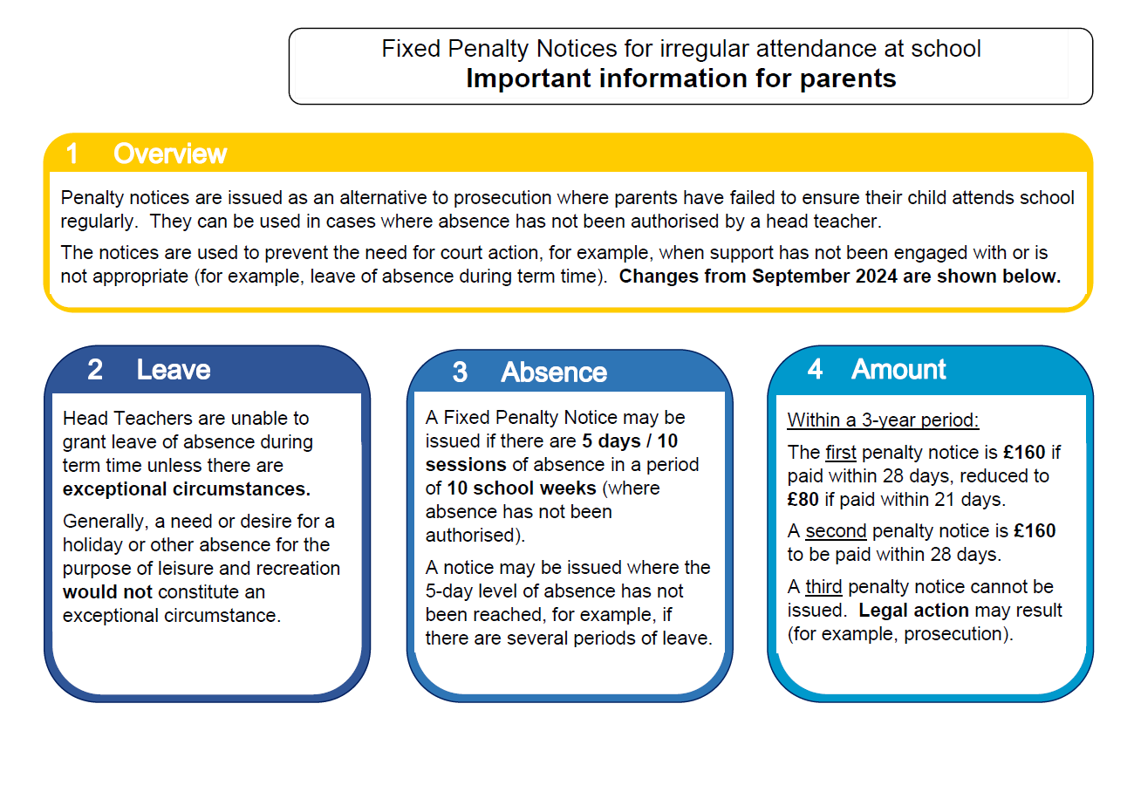
If school has reason to believe that the absence is due to a holiday, a suspected holiday letter will be issued, and the absence will be unauthorised unless medical evidence can be provided for the absence. Unauthorised absences on your child’s attendance record may mean that you are liable to incur a Fixed Penalty Notice

