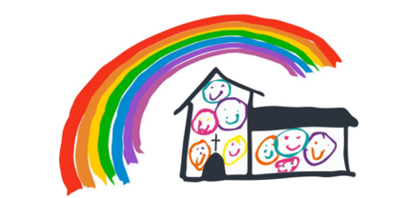

**Highburton C.E First Academy**

Behaviour and Discipline Policy

including

Governors’ Written Statement of Behaviour Principles.

Date: April 2025 Review due: Sept 2025

**Aims of the Policy**

* To encourage a calm, purposeful and happy atmosphere within the school.
* To foster positive caring attitudes towards everyone where achievements at all levels are acknowledged and valued.
* To encourage increasing independence and self-discipline so that each child learns to accept responsibility for his/her own behaviour.
* To have a consistent approach to behaviour throughout the school with parental cooperation and involvement.
* To make boundaries of acceptable behaviour clear and to ensure safety.
* To raise awareness about appropriate behaviour.
* To help pupils, staff and parents have a sense of direction and feeling of common purpose.

**Children’s Responsibilities are:**

* To work to the best of their abilities, and allow others to do the same.
* To treat others with respect.
* To obey the instructions of the school staff.
* To take care of property and the environment in and out of school.
* To co-operate with other children and adults.

**Staff Responsibilities Are:**

* To treat all children fairly and with respect.
* To raise children’s self-esteem and develop their full potential.
* To provide a challenging, interesting and relevant curriculum.
* To create a safe and pleasant environment, physically and emotionally.
* To use rules and sanctions clearly and consistently.
* To be a good role model.
* To form a good relationship with parents so that all children can see that the key adults in their lives share a common aim.
* To recognise that each is an individual.
* To be aware of children’s needs.
* To offer a framework for social education.

**The Parents’ Responsibilities Are:**

* To make children aware of appropriate behaviour in all situations.
* To encourage independence and self-discipline.
* To show an interest in all that their child does in school.
* To foster good relationships with the school.
* To support the school in the implementation of this policy.
* To be aware of the school rules and expectations.
* To offer a framework for social education.

Encouraging outstanding behaviour for learning in school:

* We make clear our expectations of good behaviour.
* We discourage unsociable behaviour by promoting mutual respect.
* We encourage children to take responsibility for their own actions and behaviour.
* We set through example standards of behaviour.
* We praise good behaviour both privately and publicly.

Good, clear and consistent management both within the context of the classroom and outside the classroom are of paramount importance in establishing good practice of behaviour and discipline within the school. As children within the framework of the school spend a lot of time within the classroom it is essential that well organised and delivered lessons will seek to secure good standards of behaviour. Bearing this in mind teachers should aim to: -

* Know their pupils as individuals. This means knowing their personalities and interests and who their friends are;
* plan and organise both the classroom and the lesson to keep pupils interested and minimise the opportunities for disruption. This may require attention to such basics as furniture layout, grouping of pupils, seating of pupils, matching work to pupils abilities, pacing lessons well, being enthusiastic and using humour to create a positive classroom atmosphere;
* be flexible in order to take advantage of unexpected events rather than being thrown off balance by them i.e. visitor at the door in the middle of a lesson;
* continually observe or 'scan' the behaviour of the class;
* be aware of, and control their own behaviour, including stance and tone of voice;
* model the standards of courtesy that they expect from pupils;
* emphasise the positive, including praise and awarding house points for good behaviour as well as good work.
* make expectations for classroom behaviour clear to pupils from the first lesson and explain why they are necessary.
* make sparing and consistent use of reprimands. This means being firm rather than aggressive, targeting the right pupil, criticising the behaviour and not the person, using private rather than public reprimands whenever possible, being fair and consistent and avoiding sarcasm and idle threats;
* make sparing and consistent use of punishments. This includes whole group punishments which children will see as unfair. It also means avoiding punishments which humiliate pupils by, for example, making them look silly.
* analyse their classroom management performance and learn from it.

All these points are interactive with all the other levels of influence highlighted before and they must be seen in that context. Everyone in the school is responsible for the behaviour and discipline and must ensure that continuity exists between all staff in school.

Where continuity exists so does security. All children in school need to know the rules of the school and indeed to have played a part in creating them. Ownership will bring about satisfaction and will be seen to reflect fair play by the children and by their parents/guardians.

In focusing on behaviour and discipline it is important that parental co-operation and support are there within the school in order that the school can move progressively forwards.

**School Rules**

Always follow instructions

Always have kind hands, feet and voice. (KS1)

Always show respect to other people and all property. (KS2)

Our school values include:

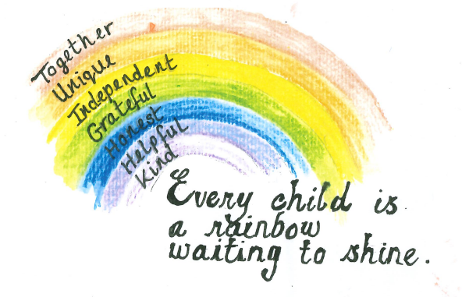

**In class and around school**

Teachers gather the attention of students with a silent signal by raising their arm and waiting for all the children to raise their arm and focus on the teacher in silence.

Teachers will use the signal 1-2-3 for transition times. 1 – children stand up out of their chair, 2 – children push their chair under, 3 – walk and follow the expectation (line up).

The meter below in used in lessons and referred to around school.

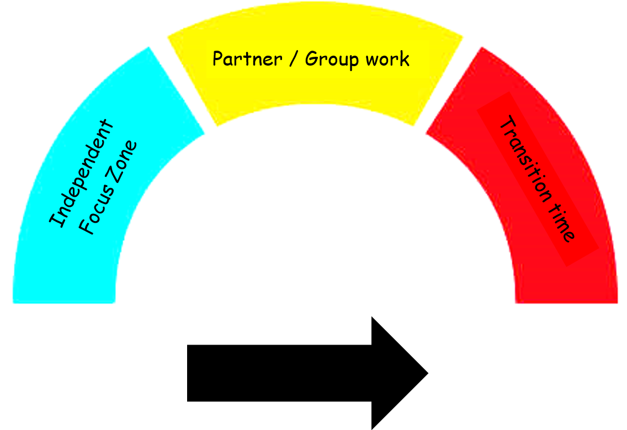

**Blue zone – Independent focus zone**

Children are expected to work independently and in silence on a set task for a limited time up to:

Year 1 – 10-12 minutes

Year 2 – 12 – 15 minutes

Year 3 – 15 -17 minutes

Year 4 – 17– 20 mins

Year 5 – 20 -25 minutes

**Yellow zone – partner/ group work**

Children are expected to work in partners or as a group discussing learning at a low level.

**Red zone – transition times**

Children are expected to move within lessons and around school in silence and sensibly.

**Rewards & Sanctions for the whole school**

*Whole School reward systems include:*

Dojos

Star of the Week

Visits to Headteacher

Mentions in assembly

Negotiated rewards chosen by class at the start of the year

Afternoon play (KS2)

Lunchtime Award

Friday Fine Diners

Headteacher’s Award

***Dojo Points***

***Children receive Dojo points for following our school values: Kind, Helpful, Honest, Grateful, Independent, Unique and Together. The adult will reward the child with a dojo point and explain why they have received one dojo point. For example, “You have got one dojo point because you were kind to your friend.”***

Our Behaviour system is as follows (see child friendly visual below):

**1. 1 dojo for recognised good behaviour linked to value**

**2. 5 dojos for recognised outstanding behaviour linked to value**

**3. Visit a teacher for positive praise**

**4. House points collated together from each class on a Friday and announced in assembly and awarded at the end of the term.**

**All members of staff can award a child a dojo for a related value by giving the child a counter to take back to their class teacher and be awarded the dojo back in class.**

**Positive peers can award children a sticker of the value they have recognised at playtime and the recipient will also then be awarded a dojo back in class.**

***Teacher’s script to be used:***

***Positive Behaviour Script***

**(Child’s name)**, you are showing our rule of **transition** by **moving through school quietly and sensibly.** I am awarding you a dojo.”

**(Child's name)**, you are showing our value of **(INSERT)** by **(describe behaviour)**. I am awarding you a dojo.

***In the event, that a child is not following our school values, the following steps will***

***take place:***

**1. B1: Quiet warning - clear, explicit expectations**

**3. B2: 2nd warning - 5 mins off next playtime (additionally move seat to work more productively)**

**4. B3: Repeated disruptive behaviour - child joins paired class to complete work (reception and year 2, year 1 and year 4, year 3 and year 5 and miss 15 minutes playtimes (1st break if morning or lunch if in after break session or following day if in afternoon) and SLT to follow up with child and discuss behaviour.**

**5. B4: More extreme behaviour e.g physical, language, child on child abuse - miss next two days of playtimes and cannot go outside for agreed days - on 3rd day, child is allowed to go at playtimes with supervision leading or join in an PE activity. Additionally, a phone call home will be made.**

If three playtimes are lost repeatedly (3 times in a week or behaviour categorised as extreme), a phone call home will be made or a letter is sent to parents inviting them to attend a meeting with the Headteacher to discuss a behaviour plan to improve behaviour.

***If a child loses time from their play time (including 5 or 15 minutes) this will be reported on CPOMS. More extreme behaviour will also be logged and recorded on CPOMS including actions taken.***

**Sanction Behaviour Script**

**B1 – Quiet Warning**  
**Script:**  
“**(Child’s name)**, this is a **quiet warning**. I’ve noticed you’re **(state the behaviour)**. I expect you to **(state the positive behaviour expected)**. This is your chance to turn it around. Let’s get back on track.”

*(Keep voice calm and neutral, and continue with teaching.*

**B2 – Second Warning (5 Minutes Off Playtime & Seat Move)**  
**Script:**  
“**(Child’s name)**, this is your **second warning – B2**. You haven’t met the expectations we talked about. You will lose **5 minutes of your next playtime**, and I’m moving you to another seat so you can focus more productively. You still have the chance to improve your choices.”

**B3 – Repeated Disruptive Behaviour (Paired Class, Loss of 15 mins Play, SLT Follow-up)**  
**Script:**  
“**(Child’s name)**, you’ve continued to show disruptive behaviour, so we’re moving to **B3**. You’ll be joining **(paired class)** to complete your work so that learning can continue. You’ll also miss **15 minutes of playtime** – today’s break/lunch or tomorrow if this is happening in the afternoon. An adult from the leadership team will talk to you later to help you reflect on this.”

**B4 – Serious or Extreme Behaviour (2 Days Playtime Loss, Supervised Return, Phone Call Home)**  
**Script:**  
“**(Child’s name)**, your behaviour today was serious. Because of this, you’ll miss the next **two days of playtimes** and won’t go outside during those times. On the **third day**, you may return to play with **adult supervision** or take part in a **supervised PE activity**, depending on how things go. I will also be calling home to speak with your parent/carer.”

**Promoting Positive Behaviour in Early Years**

In the Early Years Foundation Stage our aim is to support and understand children’s behaviour. The EYFS Statutory Framework outlines the Prime Areas of learning children develop in Reception which includes Communication and Language, Personal, Social and Emotional Development and Physical Development. The development of children’s spoken language underpins all seven areas of learning and development. Children’s back-and-forth interactions from an early age form the foundations for language and cognitive development *(EYFS Statutory Framework).*

At Highburton First Academy in EYFS, staff ensure children are nurtured through high-quality interactions to support the growth and development of children’s behaviours. We ensure all children feel safe, secure and happy. Clear rules and routines are outlined that children are expected to follow.  Staff will:

* Validate children’s feelings
* Engage in high quality interactions
* Provide comfort when sought
* Use positive language eg I can see that you may be feeling….
* Promote and praise positive behaviours
* Develop children’s understanding of right and wrong
* Teach and develop self-regulation

When behaviour needs to be addressed, children are given 1 minute of reflection time which is a brief, quiet moment to pause and begin processing what has happened. After this time, an adult will join the child to gently guide their thinking, helping them reflect on their choices, express their feelings, and explore more positive ways to respond in the future. This approach is rooted in our belief that young children learn best through secure relationships, clear boundaries, and consistent emotional support.

While most behaviours are managed effectively within the EYFS setting through positive relationships and consistent routines, there may be occasions when a child's behaviour becomes more challenging or persistent. In such cases, a member of the Senior Leadership Team will step in to support the child, the staff, and the situation. The SLT member will speak with the child in an age-appropriate and supportive manner, and will also work closely with the child’s parents or carers to ensure a consistent and collaborative approach, alongside the class teacher.

**Behaviour Support Plans**

Children with additional social and emotional needs may require a Behaviour Support Plan. See SEN Policy.

**Immediate Send Outs**

If a child is openly defiant or the teacher is unable to teach, the child should be sent immediately to a member of the Senior Management Team or the Headteacher escorted by an adult.

**Serious Incidents**

Incidents that fall outside the above procedure are managed by the Senior Leadership Team.

**Lunchtime**

The same systems are used at lunchtime. Lunchtime Supervisor can award the children a counter for a dojo and explain the value and reason they have been awarded it for. The children will then add the dojo on the platform when they are back in class.

**Phones**

Children who bring a mobile phone to school must hand in at the start of the day to their class teacher. The teacher will keep the phones in a safe locked drawer or cupboard and then given back to the child at the end of the day. The children must turn their phone off and put it away before walking in the playground at the start of the day and can then turn it back on when they are off school premises.

**Exclusion Guidance**

School follows the procedures and guidance in the Exclusions Policy and [Department of Education - Exclusion Guidance document.](https://www.gov.uk/government/uploads/system/uploads/attachment_data/file/269681/Exclusion_from_maintained_schools__academies_and_pupil_referral_units.pdf)

**Appendix 1: Governors’ written statement of behaviour principles**

* Every pupil understands they have the right to feel safe, valued and respected, and learn free from the disruption of others
* All pupils, staff and visitors are free from any form of discrimination
* Staff and volunteers set an excellent example to pupils at all times
* Rewards, sanctions and reasonable force are used consistently by staff, in line with the behaviour policy
* The behaviour policy is understood by pupils and staff The exclusions policy explains that exclusions will only be used as a last resort, and outlines the processes involved in permanent and fixed-term exclusions
* Pupils are helped to take responsibility for their actions
* Families are involved in behaviour incidents to foster good relationships between the school and pupils’ home life

The governing board also emphasises that violence or threatening behaviour will not be tolerated in any circumstances.

This written statement of behaviour principles is reviewed and approved by the full governing board annually.

