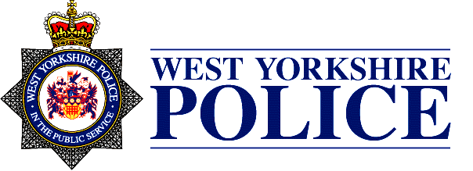

SCHOOL LOGO

Dear Parent/Guardian,

You may have seen recent reporting in the media of a phenomena known as County Lines drugs dealing. County Lines is a term used to describe gangs and organised criminal networks involved in moving and selling drugs, using dedicated mobile phone lines. This is a particularly nasty crime and often involves young people being exploited by gangs who take advantage of a power imbalance to coerce and trap young people into committing crime on their behalf. They use, intimidation, violence (including sexual violence) and weapons and target children from all backgrounds.

We are pleased to have been offered an educational input on ‘County Lines’ by West Yorkshire Police, aimed at informing children of risks and offering guidance on how to be safer.

County Lines activity and the associated violence, drug dealing and exploitation has a devastating impact on young people and their families and the input by the police aims to safeguard our pupils and offer help and support to children who may have concerns.

The presentation includes;

* A description of what County Lines is, and how this affects young people
* Some of the ways in which young people are groomed into this type of activity
* The risks involved
* The law around child criminal exploitation (CCE) and that young people who are coerced into criminal activity in this way are seen as victims by the police
* How to be safer and avoid dangerous situations
* How to report concerns or get help

[The Children’s Society offer further guidance](https://www.childrenssociety.org.uk/news-and-blogs/our-blog/how-children-and-young-people-are-forced-to-sell-drugs-through-county-lines" \o "The Children's Society)

We would like to thank you for your support of this very important safety message and are happy to answer any questions you may have around this subject.