Highburton CE First Academy

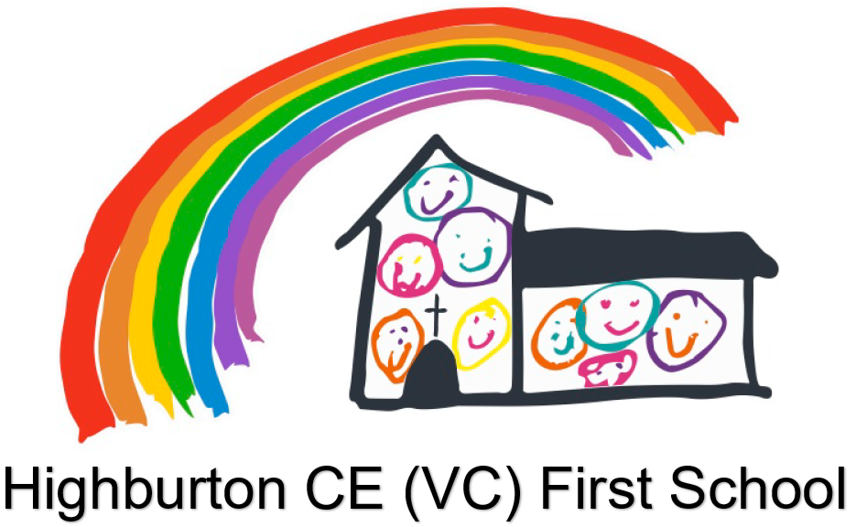

Curriculum Policy

May 2024 Review May 2026
At Highburton CE First Academy we believe that to enable our pupils to learn effectively, they need to feel safe in their environment and be both socially and emotionally ready to learn. We understand the importance of holistic development and offer nurturing and enriching experiences to enable the development of the whole child.
We recognise that some of our pupils are not always emotionally ready to learn when they come to Highburton CE First Academy and require an increased level of support for them to access the curriculum. Holding the National Nurturing Schools Award we are in a strong position to support our children’s social and emotional development.
Highburton CE First Academy aims to serve its community by providing an education of the highest quality within the context of Christian belief and practice. It encourages an understanding of the meaning and significance of faith and promotes Christian values through the experience it offers to all its pupils.
We believe that children are nourished by great opportunities and experiences.
Curriculum Intent
- Provide a broad and balanced education for all pupils
- Ignite a love of learning in all pupils and nurture a Growth Mindset.
- Enable pupils to develop knowledge, understand concepts and acquire skills, and be able to choose and apply these in relevant situations
- Support pupils’ spiritual, moral, social and cultural development
- Support pupils’ physical development and responsibility for their own health, and enable them to be active
- Promote a positive attitude towards learning
- Ensure equal access to learning, with high expectations for every pupil and appropriate levels of challenge and support
- Promote an understanding and appreciation for their community and the world in which they live and prepare them for later life.
- Develop a broad range of basic skills to enable access to learning and support future life.
- Promote the learning and development of our youngest children and ensure they are ready for Key Stage 1

Teaching and Learning at Highburton covers the National Curriculum 2014 as well as RE, PSHE including Sex and Relationships Education, Safeguarding and Basic Skills.
Democracy, the rule of law, individual liberty, and mutual respect and tolerance of those with different faiths flow throughout our school and curriculum.
In addition, this policy acknowledges the requirements for promoting the learning and development of children set out in the Statutory Framework for Early Years Foundation Stage (EYFS).
At Highburton we believe that reading is the key to the door to quality learning and success at school and beyond. We follow the National Curriculum 2014 for all our statutory subjects. The Local Curriculum for Religious Education is supplemented by Understanding Christianity - Church of England.
The knowledge and skills that pupils gain in each subject is set out in a Sequence of Learning. Each sequence works towards our end point in Year 6 that the children will complete at Middle School. Sequences of Learning can be found here on our website. The documents also illustrate how the curriculum links to our vision and values.

Curriculum Implementation
Each subject Sequence of Learning sets out end points for each year group and illustrates how the children build their knowledge and skills throughout school.
The curriculum provided for our pupils covers the following National Curriculum subjects:
- English
- Maths
- Science
- Art and Design
- Computing
- Design Technology
- Geography
- History
- Music
- PE
- RE – Kirklees Syllabus supplemented by Understanding Christianity (CofE Education Office)
- French (KS2)
- PSHE

The curriculum at Highburton is designed to prepare our pupils for their next stage of education as well as for their life as an adult. Therefore we provide opportunities for our pupils to experience the following:
- Safeguarding Curriculum
- Forest School
- Basic Skills
- Leadership Development

Safeguarding, Maths, English, French, RE, PE, PHSE, Music and Computing are taught discretely as individual subjects. Science, History, Geography, Art and Design, and Design Technology are taught in themes where possible. Forest School, and Basic Skills can work independently or fit into themes where appropriate.
We want the children to be excited about their learning and we believe that providing a mixture of discrete and thematic programmes of study excites, challenges and supports high quality teaching and learning.
We recognise and promote the key importance of the core subjects and developing the pupils’ expertise in phonics, reading, writing and maths. We aim to activate the pupils’ learning in these subjects in innovative, creative and exciting ways. We firmly believe that this should be balanced within both the whole National Curriculum and the wider school curriculum.

Early Years Foundation Stage
See our EYFS policy for information on how our Early Years Curriculum is delivered.

Educational Research
Curriculum implementation at Highburton First is supported by educational research. More information regarding this may be accessed here. A brief overview of the strategies implemented as a result of high quality educational research are listed below.
Mastery learning for mathematics has been adopted throughout school using White Rose Maths schemes of work.
Arts Participation in incorporated into our English curriculum as we have found that the children respond positively to quality texts read to them being linked to art and drama. The Power of Reading (CLPE) scheme is used to teach writing. Feedback from children regarding the PofR texts is very positive, children find them inspirational, which in turn, leads to high quality writing.
Collaborative Learning and Peer Tutoring occur throughout our Reading curriculum. Year 5 children work with Reception and Year 1 and all groups from Year 2 onwards use the Reciprocal Reading strategy when their group is working independently which relies on metacognition and self-regulation.
Metacognition and Self-Regulation enables learners to be aware of their strengths and weaknesses and use this knowledge to plan, monitor and evaluate their learning.
Feedback. Teachers teach actively, they are constantly giving verbal feedback to children which provide immediate intervention which allows the children to act upon teaching points immediately and move forward in their learning.

Curriculum Impact
Our outcomes in national tests are consistently above the national expectation. We track each child closely throughout each year to ensure that any necessary interventions may be put into place to support them if necessary.
We are a First School, this means our children leave for Middle School at the end of Year 5 therefore we do not have Key Stage 2 SAT results. In order to ensure we have evidence of our assessment judgements, Year 3, Year 4 and Year 5 pupils undertake PIRA and PUMA tests for Reading and Maths on a termly basis. These results provide us with valuable data to support our judgements.

Spiritual, Moral, Social and Cultural (SMSC)
SMSC development is integral to the life of our school. As a church school Christian Values form our core and they are the basis of our behaviour expectation and experience throughout school.
Spiritual Development

Highburton CE First Academy is a Church of England school with very strong community links to All Hallows Church in Kirkburton. The RE curriculum covers a range of faiths, whilst at the same time celebrating the distinctly Christian ethos of the school. Spirituality is where children have the opportunity to ask, reflect and discuss the ‘big questions’ in life.

Moral Development

The children at Highburton CE First Academy have a strong understanding of right and wrong. This is reinforced through the behaviour system linked to Christian Values and based on restorative practice. All classes discuss school rules at the beginning of each year which are regularly referred to.

The children show an interest in offering views about moral and ethical issues, particularly evident through our School Council. Children are given an understanding of how a democracy works through the House system. Children are divided into four houses, each house has an elected Captain and Vice-Captain and children are awarded points for their house to reward demonstrating Christian Values, good behaviour and achievement.

Social Development

The school is at the heart of a supportive, social community. Children are encouraged to use a range of social skills in different contexts, through the provision of numerous clubs, events, visits, residentials and inter-school events, for example, sports and transition. Upper Key Stage 2 Playleaders are trained at the beginning of the school year to support younger children to integrate and play well together. Befrienders are trained each September to become Peer Counsellors and they offer a counselling service to pupils in school.

Global Education Through the Curriculum

At Highburton CE First Academy, pupils develop an understanding of interdependence. This refers to the fact that the world today can no longer be thought of as a collection of distinct and isolated countries and groups of people, who live their lives totally separate from each other. Pupils develop an awareness that their own perspective is only one of many which are possible and that the choices they make can have an impact on others locally and globally.

Cultural Development

Our pupils participate in an impressive range of artistic, musical, sporting and cultural opportunities often working with pupils from other schools. Their achievement within these areas is celebrated weekly during a whole school Collective Worship during which trophies, awards and certificates are shown and discussed. As part of the RE curriculum, pupils visit a range of places of worship in order to become familiar with other religions worshiped and the people who worship in our community and globally.

Mental Health and Wellbeing

See our Mental Health and Wellbeing policy for information on mental health and wellbeing.
British Values

At Highburton CE First Academy, we actively promote the fundamental British values of:

Democracy
Pupils are introduced to Britain’s democratic parliamentary system through the School Council elections, House Captain elections, History curriculum and Behaviour policy.

Rule of Law
Pupils are taught the difference between right and wrong. They are aware of consequences and rewards due to the restorative practice of our behaviour system.

Individual Liberty
Within school, pupils are actively encouraged to make choices, knowing that they are in a safe and supportive environment. Pupils are encouraged to know, understand and exercise their rights and personal freedoms and advised how to exercise these safely, for example through our Online Safety and PSHE curriculum.

Mutual Respect
Mutual respect is at the heart of our school and is one of our core values. Pupils learn that their behaviour has an effect on their own rights and those of others. At Highburton CE First Academy, we reinforce the understanding that we are all equal with different qualities, backgrounds, interests and personalities. We celebrate personal achievements and interests.

Respect and Understanding of those of Different Faiths and Beliefs
Highburton CE First Academy is situated in an area that is not culturally diverse, therefore we place a great emphasis on exploring diversity with the children. Our RE, PSHE and SMSC teaching reinforces this. Children visit places of worship that are important to different faiths and meet and talk to people who worship there. Members of different faiths or religions are encouraged to share their knowledge to enhance learning within classes and the school.

Sex and Relationships Education

See our Sex and Relationships Education policy for information on how our Curriculum is delivered.

Inclusion
Teachers set high expectations for all pupils. They will use appropriate assessment to set ambitious targets and plan challenging work for all groups, including:
More able pupils
Pupils with low prior attainment
Pupils from disadvantaged backgrounds
Pupils with SEND
Pupils with English as an additional language (EAL)
Teachers will plan lessons so that pupils with SEN and/or disabilities can study every National Curriculum subject, wherever possible, and ensure that barriers to learning are addressed and every pupil achieving their best outcomes.
Teachers will also take account of the needs of pupils whose first language is not English. Lessons will be planned so that teaching opportunities help pupils to develop their English, and to support pupils to take part in all subjects.
Further information can be found in our Equality Policy, and in our SEND policy and information report on the school website.

Monitoring arrangements
Governors monitor coverage of National Curriculum subjects and compliance with other statutory requirements through:

- Curriculum & Standards Committee meetings and visits
- Full Governing Board meetings and visits
- Discussions with staff and pupils
- Governor Monitoring Schedule

Senior Leaders monitor coverage of the National Curriculum, wider curriculum and the quality of teaching and learning through:

- Teacher performance management
- Lesson Observations
- Work book scrutiny
- Learning Walks
- Pupil voice
- Pupil tracking
- Assessment data analysis – progress and attainment
- Planning scrutiny

Subject Leaders monitor the way their subject is taught throughout the school by:

- Work book scrutiny
- Planning scrutiny
- Learning walks
- Pupil voice

Subject Leaders also have responsibility for monitoring the way in which resources are stored and managed.

Roles and responsibilities
The governing board
The governing board will monitor the effectiveness of this policy and hold the headteacher to account for its implementation.
The governing board will also ensure that:
A robust framework is in place for setting curriculum priorities and aspirational targets
Enough teaching time is provided for pupils to cover the National Curriculum and other statutory requirements
Proper provision is made for pupils with different abilities and needs, including children with special educational needs (SEND)
The school implements the relevant statutory assessment arrangements
The Governing Board participates actively in decision-making about the breadth and balance of the curriculum

Headteacher
The headteacher is responsible for ensuring that this policy is adhered to, and that:
The school’s procedures for curriculum and assessment meet all legal requirements
The governing board is fully involved in decision-making processes that relate to the breadth and balance of the curriculum
The governing board is advised on whole-school targets in order to make informed decisions
Proper provision is in place for pupils with different abilities and needs, including children with SEN

Subject Leaders
- Subject Leaders maintain an overview of the curriculum provided by the school and work in partnership with the Senior Leadership Team on a range of strategic planning, monitoring and evaluation tasks.
- Subject Leaders work with specialists, including Local Authority subject networks and Shelley Pyramid subject networks, to ensure key concepts for the subjects are taught in depth.
- Subject Leaders review assessment of their subject to ensure that pupils’ learning becomes increasingly more challenging as they move through the year groups and to maintain an overview of standards within their subject.
- Subject Leaders produce an annual action plan for their subject, (which feeds into the School Improvement Plan) monitor progress of this and prepare annual feedback to Governors.

Class Teachers
- Class Teachers have the final responsibility to produce class specific short-term planning for their pupils.
- Class Teachers have responsibility for the standards their pupils achieve, the progress they make and the evidence of this learning.
- 2 Simple (EYFS) and Classroom Monitor assessment systems are used to support teacher assessment, planning and progression of skills and knowledge within curriculum subjects.
- Class Teachers ask for guidance from Subject Leaders when appropriate and are required to ensure all provision promotes a love of learning.

