PE Funding

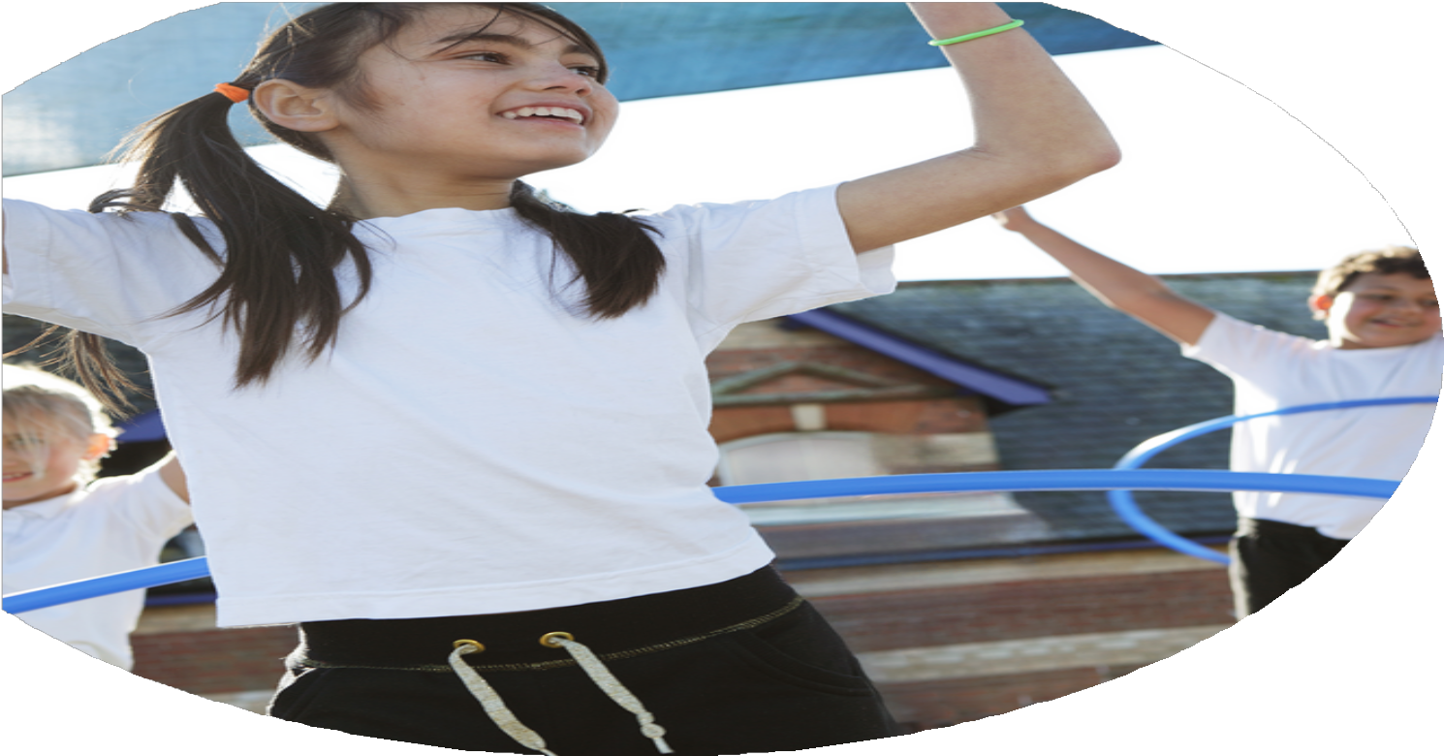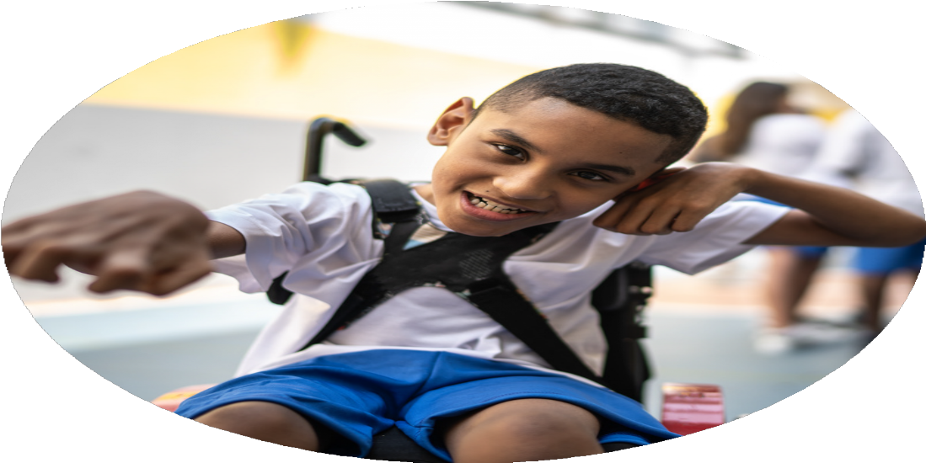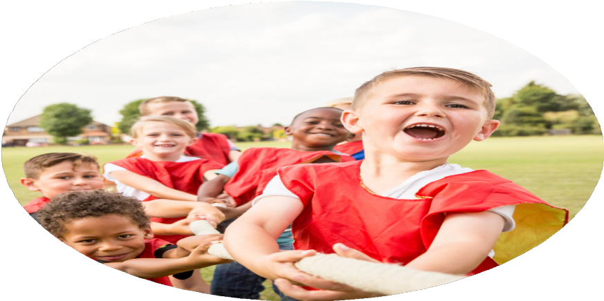

Evaluation Form

**Commissioned by**

**Created by**

Images courtesy of Youth Sport Trust

**PE Funding Evaluation Form**

 It is intended that this template should be used as preparation for the completion of the statutory digital reporting tool being introduced this academic year. You can upload data (including swimming) from this template onto this platform once it becomes accessible.

 Before you decide how you are going to use the funding for this academic year you should reflect and evaluate the impact of your use of the funding in 2023/24.

 All spending of the funding must conform with the terms outlined in the Conditions of Grant document.  The template is a working document that you can amend/update during the year.

 Based on your evaluation of last year’s funding you should decide what you intend to do this academic year, how you will do it, and what impact you expect it to have.

It is important that the funding is used effectively and based on your school’s needs.

 You must use the funding to make additional and sustainable improvements to the PE and sport in your school.  You must develop and add to the PESSPA activities that your school already offers.

*Summative digital reporting from June 2025 will continue to include swimming and water safety information therefore funding can be used to provide top-up lessons where necessary to ensure pupils meet national curriculum swimming requirements.*

All teachers were trained in terms of supporting their delivery of effect PE lessons. Some, but not all Tas, also accessed this training.

We were unable to purchase the scooters until towards the end of the academic year, therefore, the impact of having these was not as great as it could have been.

Whilst this opportunity was specifically directed at target children, of the 15 invited 8 (53 %) took part.

TA training

Scooters being used

Children who did not take part in physical activity clubs out of school during the year were invited to attend summer tennis club.

As indicated by our robust extra-curricular tracking approach.

PE board and celebration assemblies have been regularly used to promote achievements. Photos shared with parents through website and newsletter.

All teaching staff are clear of skill progression in all areas of PE and that all staff know where to access these. Teaching has been observed to ensure that skill progression is being taught.

LTS and ETAs completed modules and share activities with other members of staff to create a safe and fun environment where the children can take part in activities during break times. These activities have improved behaviour during lunchtimes and promoting health and fitness.

The number of children engaged in regular physical activity was high.

The profile and prominence of PE has been raised across all of school.

Increased confidence, knowledge and skills of all staff in teaching PE and sport

Broader experience of a range of sports and activities offered to all pupils

What are your plans for 2024/25?

Intent

How are you going to action and achieve these plans?

Implementation

* Make the most of the ‘feel good’ effect of sporting success. Allowing children to develop confidence and a positive self-image as they are part of a successful school.
* Children in all year groups have access to a marked running course, new bouldering wall, ball court activities (changed weekly) and daily exercise. Children can also take part in lunchtime activities and Play Leader led competitions.
* Portable speaker used to promote dance in the playground at lunchtimes. Shane Killock to demonstrate how he would use the scheme and adapt it. Continue to use the *Champions* scheme as the backbone of teaching. Ensuring there is a clear progression of skills in each area of PE, allow teachers to utilise their own expertise to achieve this. Use observations to ensure teaching is good or better.
* Staff to be aware of available resources to support their planning and delivery.
* External coaches delivering PE alongside teacher: rugby, orienteering, athletics, martial arts/fitness, etc. Teachers begin to build their own resource bank of planning, ideas from these observations.
* To provide scooter out of school club and lunchtime activity.
* Increase play in reception by creating a sandpit and a wild area around school.
* Travel to inter school competitions to increase competitive participation during school time for all children. Continue to participate in the Shelley Schools Sports partnership as it offers such good value for money, Additional funding for all children to access inter school competitions.

To improve the awareness of PESSPA achievements throughout school.

Increase physical opportunities for all children to get active. Introduce new playtime activities for all children to access.

To improve skill progression knowledge and confidence in PE, giving teachers an understanding of how to stretch the more able and support and develop the less confident.

Teachers to receive CPD on the Rising Stars scheme.

To ensure that all teachers have access to equipment that means all children have access to engagement in PE lessons, playtimes and extra-curricular clubs.

Increase participation in competitive inter-school competition.

What impact/intended impact/sustainability are you

expecting?

How will you know? What **evidence** do you have or

expect to have?

* Registers of extracurricular and lunchtime clubs, inter-school competitions, and in-school competitions.
* Pupil voice surveys and wellbeing questionnaires.
* Teacher CPD records, planning samples, and observations.
* Photographic evidence of new equipment and children engaging with it.
* Monitoring of PE lessons to check skill progression and teacher confidence.
* Records of Play Leader involvement and activities delivered.
* Increased participation in physical activities across all year groups through a variety of inclusive opportunities, ensuring every child is active daily.
* Enhanced pupil confidence and enjoyment of PE, leading to improved mental health and wellbeing.
* Teachers will have improved confidence, subject knowledge, and access to quality resources, ensuring long-term improvement and sustainability in PE teaching.
* The introduction of new playground equipment and activities will promote active play, with long-lasting impact on children’s daily activity levels.
* Continuing engagement in inter-school competitions will raise the profile of sport, enhance competitive skills, and build community links.
* CPD and shared planning from external coaches will ensure long-term teacher development and sustainability beyond the funding period.
* Improved Reception provision (sandpit, wild area) will foster exploration, physical development, and early gross motor skills.

What **impact/sustainability** have you seen?

What **evidence** do you have?