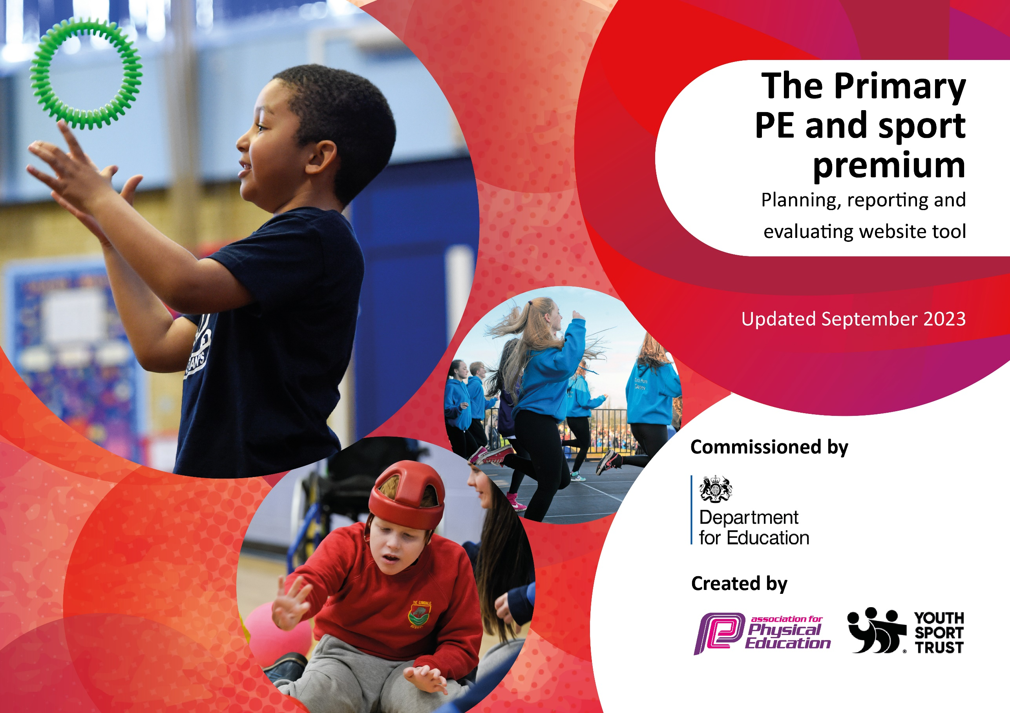

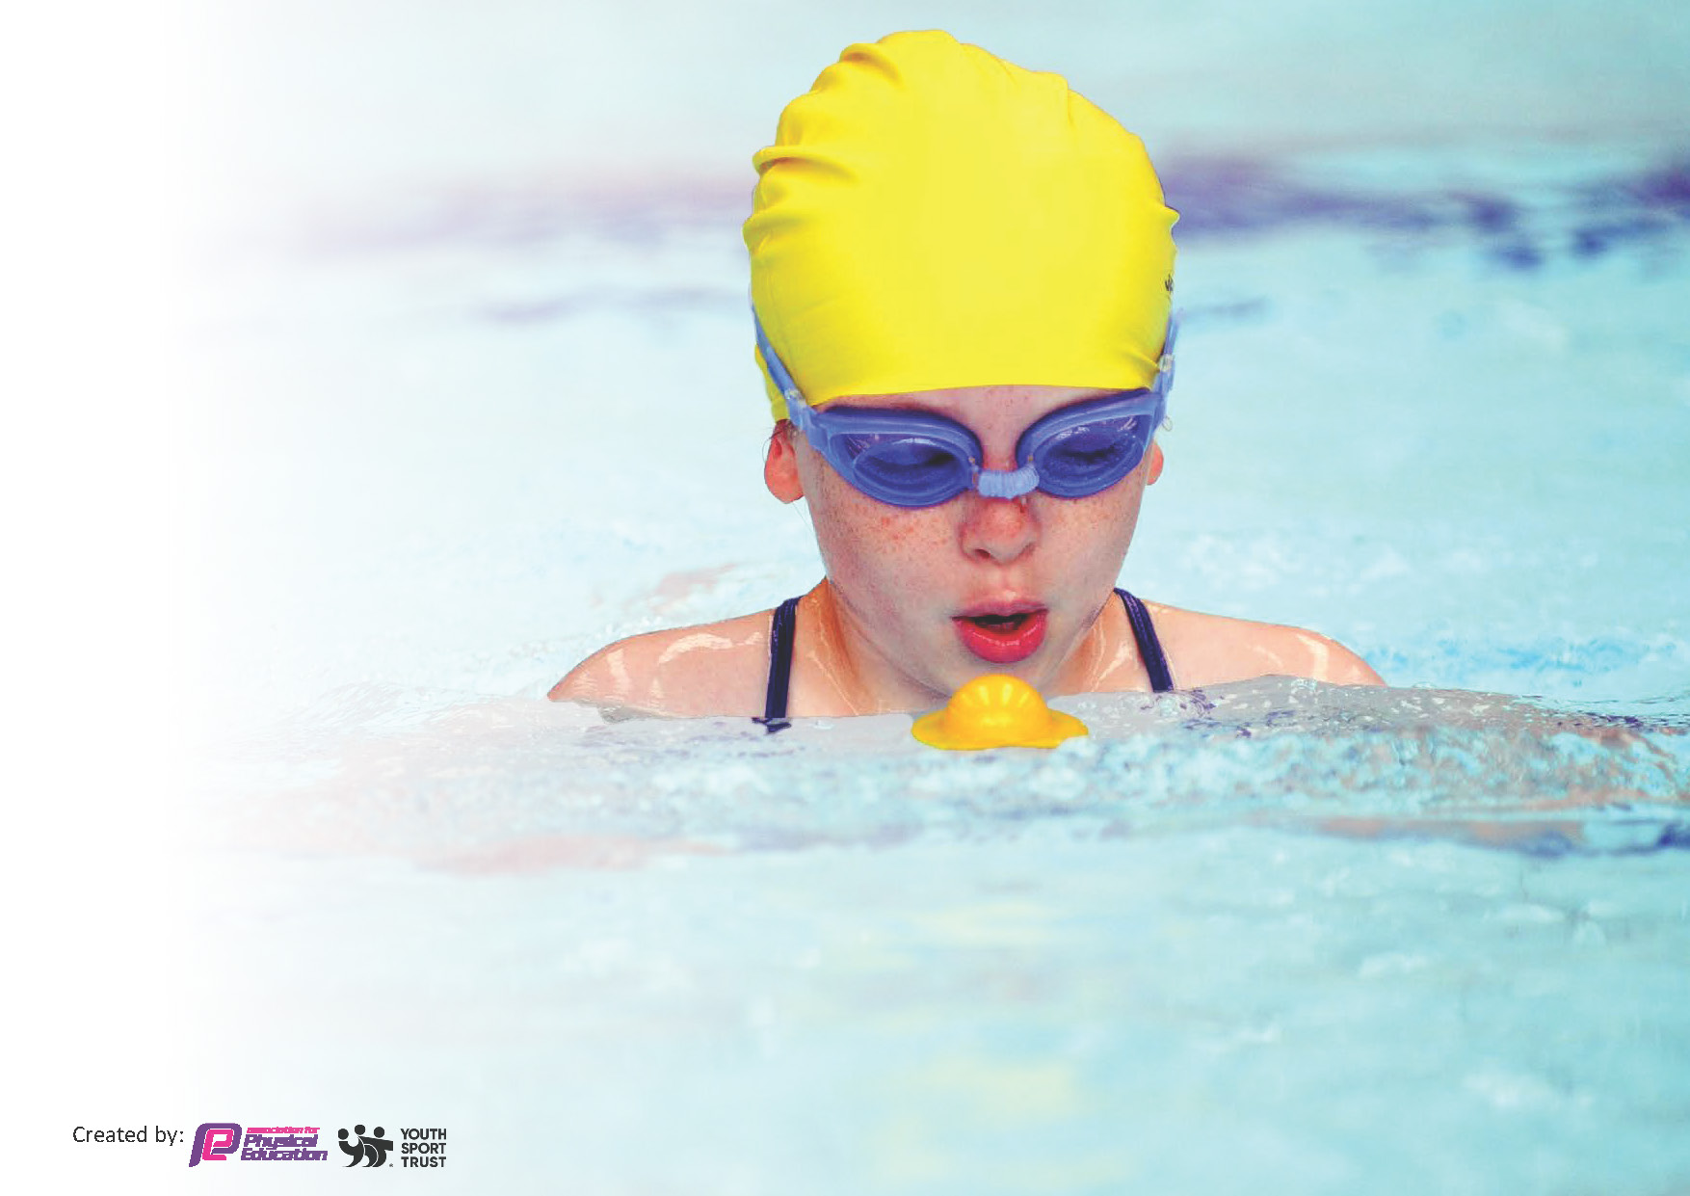
This template can be used for multiple purposes:
by:
- It enables schools to effectively plan their use of the Primary PE and sport premium
- It helps schools to meet the requirements (as set out in guidance) to publish information on their Primary PE and sport premium
- It will be an effective document to support Ofsted inspections enabling schools to evidence progress in Physical Education (PE) and evidence swimming attainment, which forms part of the PE National Curriculum. We would recommend schools consider
the Intent, Implementation and Impact of any spend, as examined within the Education Inspection Framework.

It is important that your grant is used effectively and based on school need.

Schools must use the funding to make additional and sustainable
improvements to the quality of the PE, School Sport and Physical Activity (PESSPA)
they offer. This means that you should use the Primary PE and sport premium to:

- Build capacity and capability within the school to ensure that improvements made now will benefit pupils joining the school in future years
- Develop or add to the PESSPA activities that your school already offers.

The Primary PE and sport premium should not be used to fund capital spend projects; the school’s core budget should fund these. Further detail on capital expenditure can be found in the updated Primary PE and sport premium guidance.

The Primary PE and sport premium guidance, outlines 5 key priorities that funding should be used towards. It is not

necessary that spending has to meet all the key priorities, you should select the priorities that you aim to use any funding towards.

Although completing this template is not a requirement for schools, schools are required to publish details of how they spend this funding. Schools must also outline what the impact this funding has had on pupils’ PE and sport participation and attainment and how any spending will be sustainable in the future. All funding must be spent by 31st July 2025.

The Department for Education has worked closely with the Association for Physical Education (afPE) and the Youth Sport Trust (YST) to develop this template and encourages schools to use it. This template is an effective way of meeting the reporting requirements of the Primary PE and sport premium.
Review of last year’s spend and key achievements (2023/2024)

We recommend you start by reflecting on the impact of current provision and reviewing your previous spend.

Activity/Action | Impact | Comments
Key indicator 1: The engagement of all pupils in regular physical activity – Chief Medical Officers guidelines recommend that primary school pupils undertake at least 30 minutes of physical activity a day in school | Large number of children (30%) continue to use the marked running course for running club on a Wednesday.  56% of KS1 children take part in lunchtime physical activity provided by the Year 5 play leaders.  100% of KS1 and 2 children use the trim trail and climbing frame (on a rota basis) throughout the year.  Children have a stimulating and physically challenging outlet for their energies.  Children who did not take part in physical activity clubs out of school during the year were invited to attend summer tennis club. From the 15 invited 8 (53 %) took part. 38% of those children joined the local tennis club. All gave positive feedback about the activities they took part in. All displayed a positive attitude towards sport and exercise in an exit questionnaire.  100% PP children attended a sports club this year. | Maintain a running club over the terms that allow use of the field. Add new routes and distance challenges.  Link into the Autumn term Athletics lunchtime club (Run, Jump, Throw).  Maintain and promote dance activities during the lunchtimes. Encourage children to take part in inter school dance competitions.  Continue to track the pupils to make sure of continued participation in sports activities.
Key indicator 2: The profile of PESSPA being raised across the school as a tool for whole school improvement | A number of teachers and teaching assistants attended CPD opportunities.  Planning resources from previous years (and current year) have been used in lessons to support teachers. Increased participation of children in inter-school competitions.  Continued provision of high-quality PE. Outlines where we are now, and how we can do even better.  Parent expectation at Highburton is high. At competitions parents are keen to support their children and celebrate in their (regular) success and often comment on the quality of the performances.  PE board and celebration assemblies have been regularly used to promote achievements. Photos shared with parents through website and newsletter.  The PE notice board is now the automatic ‘go to’ place for children to find out about sports events, to sign up, to promote their own event, etc.  The Play Leader display outside yr5 allows for a smooth and well organised timetable of activities to be offered at playtimes. This allows increased independence and the development of organisation and communication skills. Monitoring by PE lead and assembly feedback demonstrate this.  Increased numbers of children signing up for events this year. We have entered (or tried to) more than one team in some events. Lots of children are actively competing out of school. Children who have achieved regional status in their sport are celebrated – child in year 5 achieved West Yorkshire status in cricket. Child in year 5 playing football for Barnsley. Children are encouraged to go to trials for football and cricket.  June 2023 – Year 3/4 Girls reached the West Yorkshire final representing Kirklees.  More children arriving at school under their own steam means healthier children, healthier parents, less traffic and therefore less pollution, as well as a decrease in traffic congestion around the school which will make for better relationships between school and local residents. Bike and scooter rack is full on a daily basis. | To continue with Shelley Pyramid next year and to take up any relevant CPD opportunities that they present. To increase the level of participation in inter-school competition. To enter new competitions to increase the range of activities.  Provided a bang up to date perspective on PE assessment and what we can do to further improve. Introduce pupil-discussions as part of overall PE monitoring.  To continue to promote the PE board and assemblies. To share more success with parents through new social media platforms.  One Play Leader to take the role of looking after the board, to maintain a level of quality and organisation.  Allocate a reporter before an event, make a big deal of it, they could read it out in assembly, and make sure it happens at every event.  Current monitoring could become slightly more formal with awards for excellent practice.  Maintain notice boards and trophy display. Develop closer links with local sports clubs for sign-posting our children but also to explore coaching expertise we may be able to utilise.  Promote the racks in the newsletter, with information about Mac’s Bikes and their drive to get all children more active.  Hold special ‘scooter days’ and ‘bike days’ encouraging use of the racks. Create a range of awards for children travelling to and from school on their bike or scooter. Create special ‘whizz’ sessions for children regularly using the racks.
Key indicator 3: Increased confidence, knowledge and skills of all staff in teaching PE and sport | All KS1 staff are clear of skill progression in all areas of PE and that all staff know where to access these. Observed teaching and to ensure that skill progression is being taught.  Teachers have a usable method of assessment which feeds directly into the whole-school Insight assessment system. Attainment is measured and both G&T and children working below expectations are identified and flagged up to PE lead.  Staff have attended a number of courses this year including: tennis, gymnastics, athletics, field sports, cricket, etc. and a sports conference. Ongoing verbal communication with staff on what areas of PE subject knowledge they need more CPD on. Lesson observations identify pupil’s receiving high quality PE. | Continue to seek out opportunities for skill development. Maintain observations. Make staff aware of opportunities to observe coaches visiting school and new equipment arriving in school.  Continue to take feedback from teachers: useful, achievable? Etc. To continue to develop assessment – looking at other schools’ assessment and discussions with SSCO and other PE leads.  Continue to seek out opportunities for less confident staff to upskill themselves. Provide Cover Supervisors and HLTA with training to raise their confidence and expertise.
Key indicator 4: Broader experience of a range of sports and activities offered to all pupils | LTSA maintained current sporting activities and encourage further opportunities at lunchtime.  LTS and ETAs completed modules and share activities with other members of staff to create a safe and fun environment where the children can take part in activities during break times. These activities have improved behaviour during lunchtimes and promoting health and fitness.  Scooters were bought and a scooter cub open to KS1 and KS2 for after school.  A broader range of activities are already being played in the ball court and there has been an increase in the numbers of girls using it. Problems that have occurred in the past related to overly-aggressive football play have disappeared. Scheduled football is now something to be enjoyed by larger numbers of both boys and girls. | Take ideas from pupils for new activities. i.e. hoola hooping challenge or a strength and conditioning themed lunchtime programme on the grass. Continue offering new or unusual activities throughout the year.  Continue to place photographs in the newsletter showing children smiling and enjoying themselves taking part in the activities such as: Teck Ball, dodgeball, scootering etc.  Monitor the new activities to assess who is taking part and how popular they are. Talk to SSCO and other PE leads to find out if other schools have any good ideas.  Train up Play Leaders to introduce and coordinate new activities.
Key indicator 5: Increased participation in competitive sport | High numbers of children have signed up for opportunities to represent the school and we have entered more than one team whenever possible in every event.  New competitions accessed in Cross Country. Success in many competitions.  The end of year PE questionnaire indicated the high value many children put on PE and particularly representing the school  All children receive the same opportunity to take part in inter school competitions. This will help children to compete in competitions who would normally be reluctant to attend.  Trust competition (football tournament ) organised end of the year. | To continue to enter and promote success in these competitions. To try and enter new competitions to ensure that all children can access competitive sport outside of lessons.  To take all opportunities for children to participate in inter-school competitions.  Continue to fund competitions and look for further opportunities of a similar nature (link to academy schools).

Key priorities and Planning
This planning template will allow schools to accurately plan their spending.

Action – what are you planning to do | Who does this action impact? | Key indicator to meet | Impacts and how sustainability will be achieved? | Cost linked to the action
To improve the awareness of PESSPA achievements throughout school.  Make the most of the ‘feel good’ effect of sporting success. Allowing children to develop confidence and a positive self-image as they are part of a successful school. | All staff and Pupils | Key indicator 2 - The profile of PESSPA being raised across the school as a tool for whole school improvement | More children wanting to compete in competitions inside and outside of school. Children becoming more confident in other subjects of the curriculum due to there increased confidence. Children and parents recognise the importance of exercise and sport. | Cost part of Shelley Sports Partnership
Children in all year groups have access to a marked running course, new bouldering wall, ball court activities (changed weekly) and daily exercise. Children can also take part in lunchtime activities and Play Leader led competitions.  Increase physical opportunities for all children to get active. Introduce new playtime activities for all children to access.  Portable speaker used to promote dance in the playground at lunchtimes. | Pupils – they will be taking part. Playleaders – Lunchtime supervisors trained in delivering the activity.  Lunchtime Supervisors.  SSCO to train sports leaders | Key Indicator 4 - Broader experience of a range of sports and activities offered to all pupils  Key indicator 1: The engagement of all pupils in regular physical activity – Chief Medical Officers guidelines recommend that primary school pupils undertake at least 30 minutes of physical activity a day in school | Children are more active at lunchtimes.  More pupils meeting their daily physical activity goal, more pupils encouraged to take part in PE and Sport Activities.  Increased participation at lunchtime.  Encourage children to take part in inter school cross county competitions | £9540
To improve skill progression knowledge and confidence in PE, giving teachers an understanding of how to stretch the more able and support and develop the less confident.  Teachers to receive CPD on the Rising Stars scheme. Shane Killock to demonstrate how he would use the scheme and adapt it.  Continue to use the Champions scheme as the backbone of teaching. Ensuring there is a clear progression of skills in each area of PE, allow teachers to utilise their own expertise to achieve this. Use observations to ensure teaching is good or better.  Staff to be aware of available resources to support their planning and delivery.  External coaches delivering PE alongside teacher: rugby, orienteering, athletics, martial arts/fitness, etc. Teachers begin to build their own resource bank of planning, ideas from these observations. | Teachers | Key indicator 3 -Increased confidence, knowledge and skills of all staff in teaching PE and sport | Quality PE lessons and out of school clubs being taught by in house trained teachers. | Cost part of Shelley Sports Partnership
To ensure that all teachers have access to equipment that means all children have access to engagement in PE lessons, playtimes and extra-curricular clubs.  To provide scooter out of school club and lunchtime activity.  Increase play in reception by creating a sandpit and a wild area around school. | Teachers, delivering activities. Lunchtime supervisors. | Key indicator 1 - The engagement of all pupils in regular physical activity – the Chief Medical Officer guidelines recommend that all children and young people aged 5 to 18 engage in at least 60 minutes of physical activity per day, of which 30 minutes should be in school.  Key indicator 4: Broader experience of a range of sports and activities offered to all pupils. | More pupils meeting their daily physical activity goal, more pupils encouraged to take part in PE and Sport Activities. | £1628  £1318  £707
Increase participation in competitive inter-school competition.  Travel to inter school competitions to increase competitive participation during school time for all children.  Continue to participate in the Shelley Schools Sports partnership as it offers such good value for money,  Additional funding for all children to access inter school competitions. | Teachers and ETAs to facilitate these competitions.  SSCO – organized events | Key indicator 5: Increased participation in competitive sport | 100% of our children will have the opportunity to take part in competitive sporting events throughout the year.  Create a positive profile for sports competitions through assemblies, newsletters, social media, school notice boards and teacher input. This will inspire children to be involved.  Staff will offer their time to attend events maximising our ability to enter all competitions. Enter competitions at B and C level whenever possible so the less able can also take part. | Cost part of Shelley Sports Partnership

Continue to buy into the Shelley Pyramid Sports Partnership, in order to access sport coaches, competition, CPD and the development of pupils, i.e. Play Leader training. Provide further support, as needed, to maintain the provision once funding has been removed. | All Teachers | Key Indicator 1: Increased confidence, knowledge, and skills of all staff in teaching PE and sport.  Key indicator 5: Increased participation in competitive sport. | Primary teachers more confident to deliver effective PE supporting pupils to undertake extra activities inside and outside of school, including teaching water safety and swimming and as a result improved % of pupil’s attainment in PE. | £4878

Key achievements 2023-2024
This template will be completed at the end of the academic year and will showcase the key achievements schools have made with their Primary PE and sport premium spending.

Activity/Action | Impact | Comments
CPD for staff through coaches and forest schools.  Scooter equipment bought to provide scooter activities in all year groups as well as after school clubs.  SSCO subscription. School games competitions.  Clubs in sports such as tennis, athletics and boxercise.  Engage in sports week. SEND festivals. PE lessons are twice a week. Outdoor equipment taken out. Brain breaks to be active. Sports clubs. | Key indicator 3: Increased confidence, knowledge and skills of all staff in teaching PE and sport.  Key indicator 4: Broader experience of a range of sports and activities offered to all pupils  Key indicator 3: Increased confidence, knowledge and skills of all staff in teaching PE and sport.  Key indicator 5: Increased participation in competitive sport  Key indicator 2: The profile of PESSPA being raised across the school as a tool for whole school improvement  Key indicator 1: Ensuring that children engage in at least 30 minutes of regular physical activity a day in school, outside of PE lessons. | Staff felt confident and lessons show better progression and understanding.  Children had wider opportunities to take part in a range of sports through extracurricular activities.  Staff had support through the scheme. Diagrams, videos and key knowledge provided.  Children understanding competition and aiming to improve.  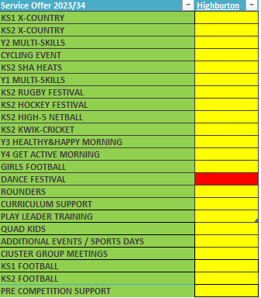  Children becoming more engaged through precise targeting of pupils to engage. Children are able to be physically active 30 minutes per day in a range of ways.

Swimming Data 2022/23
Meeting National Curriculum requirements for swimming and water safety.
Priority should always be given to ensuring that pupils can perform safe self-rescue even if they do not fully meet the first two requirements of the National Curriculum programme of study

Question | Stats: | Further context  Relative to local challenges
What percentage of your current Year 6 cohort can swim competently, confidently and proficiently over a distance of at least 25 metres? | 100% (Year 5 Cohort)
What percentage of your current Year 6 cohort can use a range of strokes effectively [for example, front crawl, backstroke, and breaststroke]? | 86% (Year 5 Cohort)

What percentage of your current Year 6 cohort are able to perform safe self-rescue in different water-based situations? | 50%
If your schools swimming data is below national expectation, you can choose to use the Primary PE and sport premium to provide additional top-up sessions for those pupils that did not meet National Curriculum  requirements after the completion of core lessons. Have you done this? | Yes/No
Have you provided CPD to improve the knowledge and confidence of staff to be able to teach swimming and water safety? | Yes/No

Signed off by:

Head Teacher: | Graham Booth
Subject Leader or the individual responsible for the Primary PE and sport premium: | Graham Booth
Governor: | Neil Hollis
Date: | 15.7.24

