**Useful Phone Apps (Best supported by an adult)**

**Anxiety**

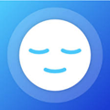 **Mindshift:** is a free app designed to help teens and young adults cope with anxiety. It can help you change how you think about anxiety. Produced by Anxiety Canada for Health Young Minds, <https://www.anxietybc.com/resources/mindshift-app>

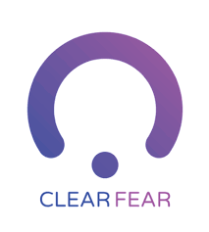 Face your fear with the free Clear Fear app and learn to reduce the physical responses to threat as well as changing thoughts and behaviours and releasing emotions.

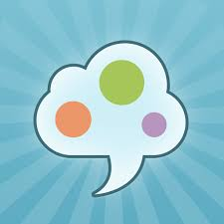 **SAM** (Self-help for anxiety management) targets individuals experiencing symptoms of anxiety. It provides users with a symptom tracker, educational articles and external links, relaxation techniques, and additional coping skills and practice for managing anxiety. Free with in-app purchases

**Rootd:** You can work on improving your panic and anxious mood while supporting a female-led app. In addition to mindfulness exercises and step-by-step guides to tactics such as deep breathing, the app features an emergency contact button that makes it simple to call a loved one or hotline when you’re in distress. Free with in-app purchases

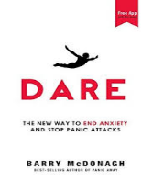 **Dare:** about facing your fears, whether you’re dealing with anxiety, panic, worry, or insomnia. The Dare app can walk you through audio recordings to help you sit comfortably with your anxiety rather than avoiding it, a tactic that can just make anxiety worse.

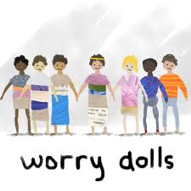**Worrydolls** is a simple, free app that helps you track your worries. It uses cognitive behavioural therapy, mindfulness, and magic to help anxious people feel better. Inspired by tiny magical dolls given to me by my grandmother.

 **Headspace**: Everyday Mindfulness and Meditation for Stress, Anxiety, Sleep, Focus, Fitness, and More. Find Out What Mindfulness Can Do for You in Just 3 Minutes a Day. Basic package free with in-app purchases

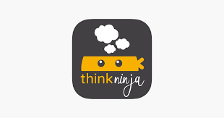**ThinkNinja –** Helping 10-18 year olds with anxiety through videos and activities

**Sleep**

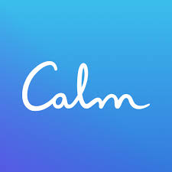 **Calm**: Find Your Favourite Music Tracks for Focus, Sleep and Relaxation. Free Trial with in-app purchases

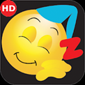 **The Ultimate Sleep App**. Instantly relax your overactive mind, so you're sleeping soundly, getting you ready to take on the day! How long since you experienced that?

**Low Mood**

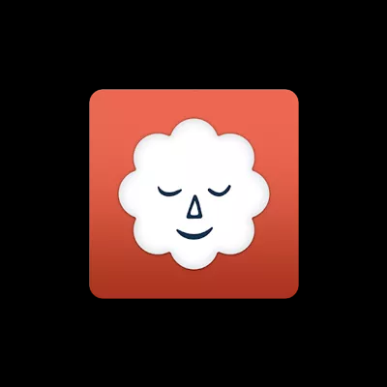 **Stop, Breathe, and Think** is your daily mindfulness app that also prompts you to input how you’re feeling. Select your mood when you open the app and it will suggest the meditations, yoga sequences, or acupressure that could serve you best in that moment, from deep breathing exercises to body scans to visualizations. The check-in feature also allows you to track your moods and progress, so you can examine what you feel most and focus on taming or understanding those anxieties better.

**Daylio** enables you to keep a private diary without having to type a single line. Try this beautifully designed micro-diary app right now for FREE!

 **Sanvello:** provides space for you to track your moods, health, and habits, offering relaxation techniques and mindfulness exercises tailored to your specific needs. Free access with in-app purchases and parental guidance advised.

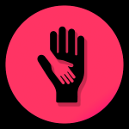 **What’s Up**: free app that uses Cognitive Behavioral Therapy (CBT) and Acceptance Commitment Therapy (ACT) methods to help you cope with Depression, Anxiety, Stress, and more. Use the positive and negative habit tracker to maintain your good habits, and break those that are counterproductive. We particularly love the “Get Grounded” page, which contains over 100 different questions to pinpoint what you’re feeling, and the “Thinking Patterns” page, which teaches you how to stop negative internal monologues. Try it out for yourself.

**4+**

**Emotional Well-being Support**

 Combined Minds is an app developed for teenage mental health charity stem4 by Dr Nihara Krause, Consultant Clinical Psychologist, to help families and friends support young people with their mental health.

 **Happify**: With its psychologist-approved mood-training program, the Happify app is your fast-track to a good mood. Try various engaging games, activity suggestions, gratitude prompts and more to train your brain as if it were a muscle, to overcome negative thoughts. The best part? Its free!

 **The Happy Child - Parenting App** grants you access to cutting-edge research and tips that will help you raise a happy, well-adjusted child. Years of ground-breaking research and findings in Psychology, Neuroscience and Paediatrics have been curated into one easy-to-use app… for free (no in-app-purchases)!

 **Silk Art** - Relax and create beautiful flowing art

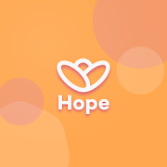 **Hub of Hope -** believes that no matter what you're going through, you shouldn't have to do it alone. Find services local to you using geolocation technology.  
The stigma associated with mental health can make it difficult to talk about, however there are services out there with people who understand and are ready to help.

 The **Shine app** is your support system for daily stress and anxiety. Learn a new self-care strategy every day, get support from a diverse community, and explore an audio library of over 500+ original meditations, bedtime stories, and ambient music to help you shift your mindset or mood.

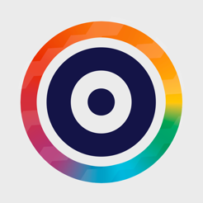The Own it app is part of the BBC’s commitment to supporting young people in today’s changing digital environment. It will provide a helping hand to your child when they receive their first smartphone, supporting their digital wellbeing, showing them how to make smarter and better informed choices and helping them grow into confident, positive and happy digital citizens.

**Self-Harm**

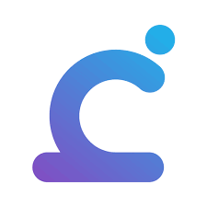**Calm Harm:**  provides tasks to help you resist or manage the urge to self-harm. Get started by setting your password so that it's completely private.  
You can personalise it if you wish, by choosing the background colour theme and deciding on whether you would like some company using a variety of friendly characters.

**OCD**

**nOCD** was designed with the help of OCD specialists and patients to incorporate two treatments: mindfulness and Exposure Response Prevention Treatment. You can receive immediate, clinically-supported guidance when an OCD episode strikes, take weekly tests to assess the severity of your OCD, and have motivational support along the way. One user calls nOCD “a free therapist in your pocket!”

 **GG OC** aims to improve OCD symptoms by increasing the user’s awareness of negative thoughts and training the brain to push those aside to embrace a more positive outset. The app takes the users through various levels, each consisting of short games around a specific theme. From how to automatically replace negative self-talk with positive thoughts, to belief in change, building self-esteem and more, this app takes its user on a journey towards a healthier thinking pattern.